DAY 1 LAB EXPERIMENTS

Name: M.Satyanarayana
Reg.no: 192472029
Dept: B.Tech CSE (AI)

1. Scenario: You are working on a project that involves analyzing student performance data for a
class of 32 students. The data is stored in a NumPy array named student_scores, where each row
represents a student and each column represents a different subject. The subjects are arranged in the
following order: Math, Science, English, and History. Your task is to calculate the average score for
each subject and identify the subject with the highest average score.
Question: How would you use NumPy arrays to calculate the average score for each subject and
determine the subject with the highest average score? Assume 4x4 matrix that stores marks of each
student in given order.
Solution:
import numpy as np
import pandas as pd
student_scores = np.loadtxt("/content/score.csv",delimiter=",",skiprows=1,usecols=(1, 2, 3, 4))
subjects = ["Math", "Science", "English", "History"]
average_scores = np.mean(student_scores, axis=0)
for i in range(len(subjects)):
print(subjects[i], ":", round(average_scores[i],2))
highest_subject = subjects[np.argmax(average_scores)]
print("Subject with highest average score:", highest_subject)

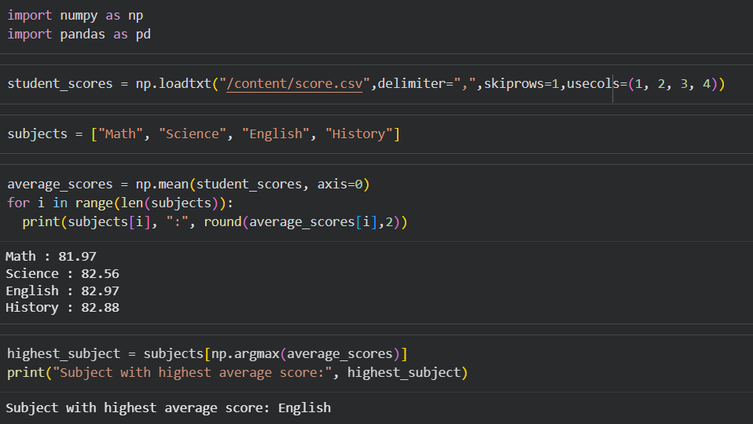
2.Scenario: You are a data analyst working for a company that sells products online. You have
been tasked with analyzing the sales data for the past month. The data is stored in a NumPy array.
Question: How would you find the average price of all the products sold in the past month?
Assume 3x3 matrix with each row representing the sales for a different product
Solution:
import pandas as pd
df = pd.read_csv("/content/Sales.csv",
usecols=["Month_sales", "Price"])
df["Month_sales"] = df["Month_sales"].astype("category")
avg_price_per_month = (
df.groupby("Month_sales", observed=True)["Price"].mean()
)
print(avg_price_per_month)
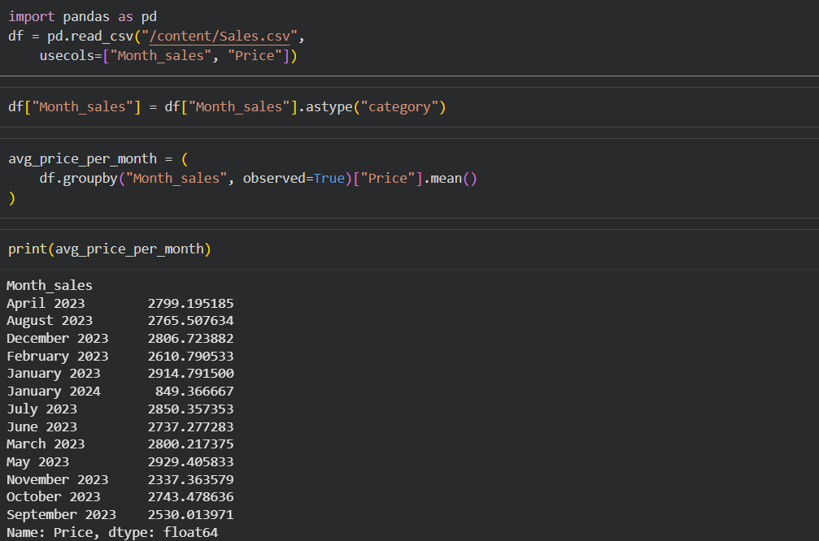

3. Scenario: You are working on a project that involves analyzing a dataset containing information
about houses in a neighborhood. The dataset is stored in a CSV file, and you have imported it into a
NumPy array named house_data. Each row of the array represents a house, and the columns
contain various features such as the number of bedrooms, square footage, and sale price.
Question: Using NumPy arrays and operations, how would you find the average sale price of
houses with more than four bedrooms in the neighborhood?
Solution:
import numpy as np
import pandas as pd
house_data = np.genfromtxt(
'/content/sample_data/House_Prediction.csv',
delimiter=',',
skip_header=1,
dtype=float
)
filtered = house_data[house_data[:, 1] > 4]
avg_price = np.mean(filtered[:, -1])
print("Average Sale Price of houses with more than 4 bedrooms: ",round(avg_price,2))

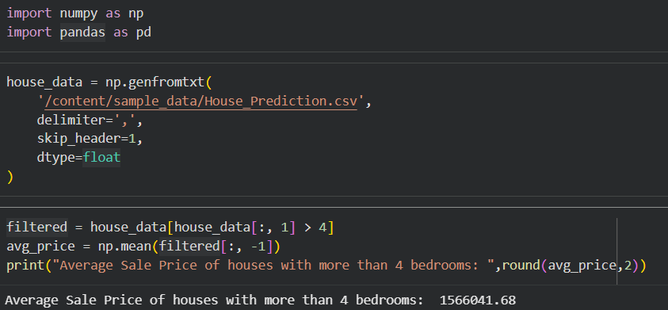

4. Scenario: You are working on a project that involves analyzing the sales performance of a
company over the past four quarters. The quarterly sales data is stored in a NumPy array named
sales_data, where each element represents the sales amount for a specific quarter. Your task is to
calculate the total sales for the year and determine the percentage increase in sales from the first
quarter to the fourth quarter.
Question: Using NumPy arrays and arithmetic operations calculate the total sales for the year and
determine the percentage increase in sales from the first quarter to the fourth quarter?
Solution:
import numpy as np
import pandas as pd
data = np.genfromtxt(
"/content/Sales.csv",
delimiter=",",
dtype=str,
skip_header=1
)

months = data[:, 1]
sales = data[:, 4].astype(float)
quarters = np.zeros(len(months), dtype=int)

for i, m in enumerate(months):
if "Jan" in m or "Feb" in m or "Mar" in m:
quarters[i] = 1
elif "Apr" in m or "May" in m or "Jun" in m:
quarters[i] = 2
elif "Jul" in m or "Aug" in m or "Sep" in m:
quarters[i] = 3
else:
quarters[i] = 4

Q1 = sales[quarters == 1].sum()
Q2 = sales[quarters == 2].sum()
Q3 = sales[quarters == 3].sum()
Q4 = sales[quarters == 4].sum()

total_sales = np.sum(sales)
percentage_increase = ((Q4 - Q1) / Q1) * 100
print("Total Sales for the Year:", round(total_sales,2))
print("Percentage Increase from Q1 to Q4:", round(percentage_increase,2))

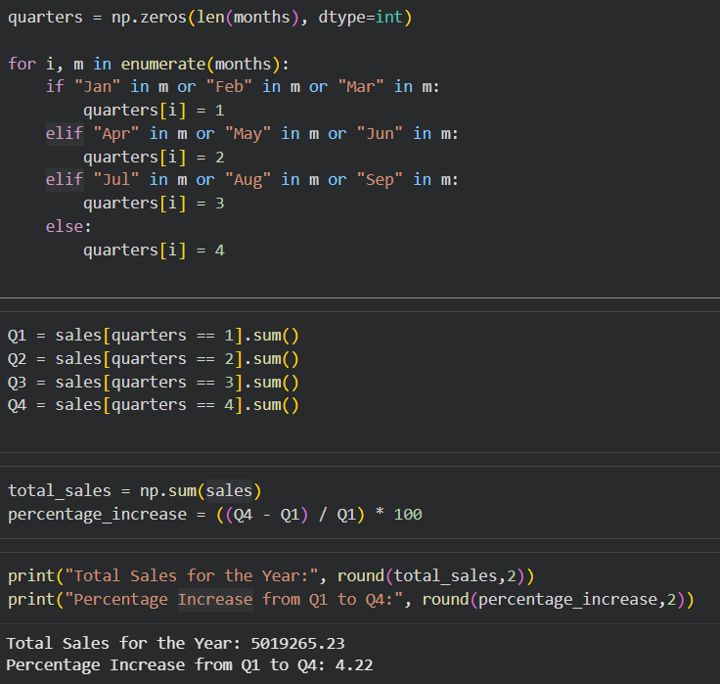

5. Scenario: You are a data analyst working for a car manufacturing company. As part of your
analysis, you have a dataset containing information about the fuel efficiency of different car
models. The dataset is stored in a NumPy array named fuel_efficiency, where each element
represents the fuel efficiency (in miles per gallon) of a specific car model. Your task is to calculate
the average fuel efficiency and determine the percentage improvement in fuel efficiency between
two car models.
Question: How would you use NumPy arrays and arithmetic operations to calculate the average
fuel efficiency and determine the percentage improvement in fuel efficiency between two car
models?
Solution:
import numpy as np
import pandas as pd
import numpy as np

data = np.genfromtxt(
'/content/fuel.csv',
delimiter=',',
dtype=str,
skip_header=1
)
highway_mpg = data[:, 7].astype(float)
average_mpg = np.mean(highway_mpg)
model1 = "mustang"
model2 = "forester awd"
model_column = data[:, 9]
mpg1 = highway_mpg[model_column == model1]
mpg2 = highway_mpg[model_column == model2]
print("Average Highway MPG:", round(average_mpg,2))
if len(mpg1) > 0 and len(mpg2) > 0:
old = mpg1[0]
new = mpg2[0]

improvement = ((new - old) / old) * 100
print("Percentage Improvement:", round(improvement,2), "%")
else:
print("Model not found in dataset")

